Steps to create an html page from a PSD

>Create a text file page.html and add the following contents to it

*<!DOCTYPE html>*

*<html lang="en">*

*<head>*

*<meta charset="utf-8">*

*<meta http-equiv="X-UA-Compatible" content="IE=edge">*

*<meta name="viewport" content="width=device-width, initial-scale=1">*

*<title></title>*

*</head>*

*<body>*

*</body>*

*</html>*

> Look for independent elements in your psd.

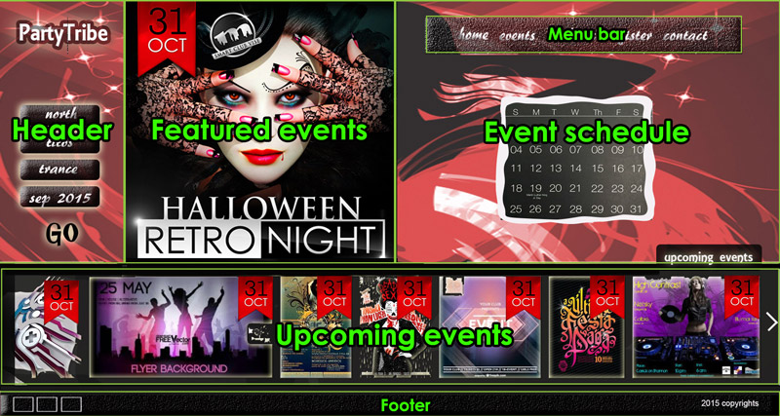

> HTML5 gives a collection tags that each have a different semantic meaning.

> We have to match the element to the HTML tag semantically.

* Following are the elements identified:
  + Header – <header>
  + Featured events – <section>
  + Event schedule - <section>
  + Menu bar - <nav>
  + Upcoming events - <section>
  + Footer - <footer>

> You have to further identify each of the above element’s child elements and identify which HTML tag to use while building each of them.

> Create a folder in the same directory as page.html and name it ‘styles’.

> Create a file called style.less in the folder styles.

> Add a link to the LESS file within the <head> tag in page.html

<link rel="stylesheet/less" type="text/css" href="styles/style.less">

> LESS is a CSS preprocessor and you require to add the less.js script below link to the LESS file in order to convert the LESS code to CSS on the fly. The LESS file is only used during development. The LESS file is then converted to CSS before deploying the html page to the production server.

*<link rel="stylesheet/less" type="text/css" href="styles/style.less">*

*<script type="text/javascript">*

*less = { env: 'development' };*

*</script>*

*<script src="js/less.min.js"></script>*

> Add each identified element within the <body> tag. And set id for them. Eg. <section id=”event-schedule”></section>, it is common practice to use a hyphen ‘-‘ for separating words while naming HTML elements.

> Add link to reset.css file

<link rel="stylesheet/less" type="text/css" href="styles/reset.css">

*<body>*

*<div class="container-fill">*

*<div class="row">*

*<header id="sidebar">*

*<a id="logo">*

*PartyTribe*

*</a>*

*<form id="search-form">*

*</form>*

*</header>*

*<section id="featured-events">*

*</section>*

*<section id="event-schedule">*

*</section>*

*</div>*

*<section id="upcoming-events">*

*</section>*

*<footer>*

*</footer>*

*</div>*

*</body>*

*/\* BOC CSS Reset \*/*

*/\* http://meyerweb.com/eric/tools/css/reset/*

*v2.0 | 20110126*

*License: none (public domain)*

*\*/*

*@import url(http://fonts.googleapis.com/css?family=Muli);*

*@import url(http://fonts.googleapis.com/css?family=Oswald);*

*html, body, div, span, applet, object, iframe,*

*h1, h2, h3, h4, h5, h6, p, blockquote, pre,*

*a, abbr, acronym, address, big, cite, code,*

*del, dfn, em, img, ins, kbd, q, s, samp,*

*small, strike, strong, sub, sup, tt, var,*

*b, u, i, center,*

*dl, dt, dd, ol, ul, li,*

*fieldset, form, label, legend,*

*table, caption, tbody, tfoot, thead, tr, th, td,*

*article, aside, canvas, details, embed,*

*figure, figcaption, footer, header, hgroup,*

*menu, nav, output, ruby, section, summary,*

*time, mark, audio, video {*

*margin: 0;*

*padding: 0;*

*border: 0;*

*font-size: 100%;*

*font: inherit;*

*vertical-align: baseline;*

*}*

*/\* HTML5 display-role reset for older browsers \*/*

*article, aside, details, figcaption, figure,*

*footer, header, hgroup, menu, nav, section {*

*display: block;*

*}*

*body {*

*line-height: 1;*

*}*

*ol, ul {*

*list-style: none;*

*}*

*blockquote, q {*

*quotes: none;*

*}*

*blockquote:before, blockquote:after,*

*q:before, q:after {*

*content: '';*

*content: none;*

*}*

*table {*

*border-collapse: collapse;*

*border-spacing: 0;*

*}*

*/\* EOC: CSS Reset \*/*

> Identify the size of each section in terms of percentage in proportion to the screen size. Eg. The element Width=300px and the screen width=1920px then the percentage width=300/1920\*100=15.625% (you can keep the fraction part)

> To make a flexible group of elements ordered either in a row or column you can use flexbox (CSS3).

> In the above example the proportion of the Header, Feature events and Event schedule elements are 15%, 35% and 50% respectively. Therefore the flex CSS property has to set to 15, 35 and 50 respectively in the less file.

> In order to make height of the sections to resize in proportion to the width, you can use vw (viewport width) and vh (viewport height) measuring units instead of px (pixels).